Setting up your VBIT-PI

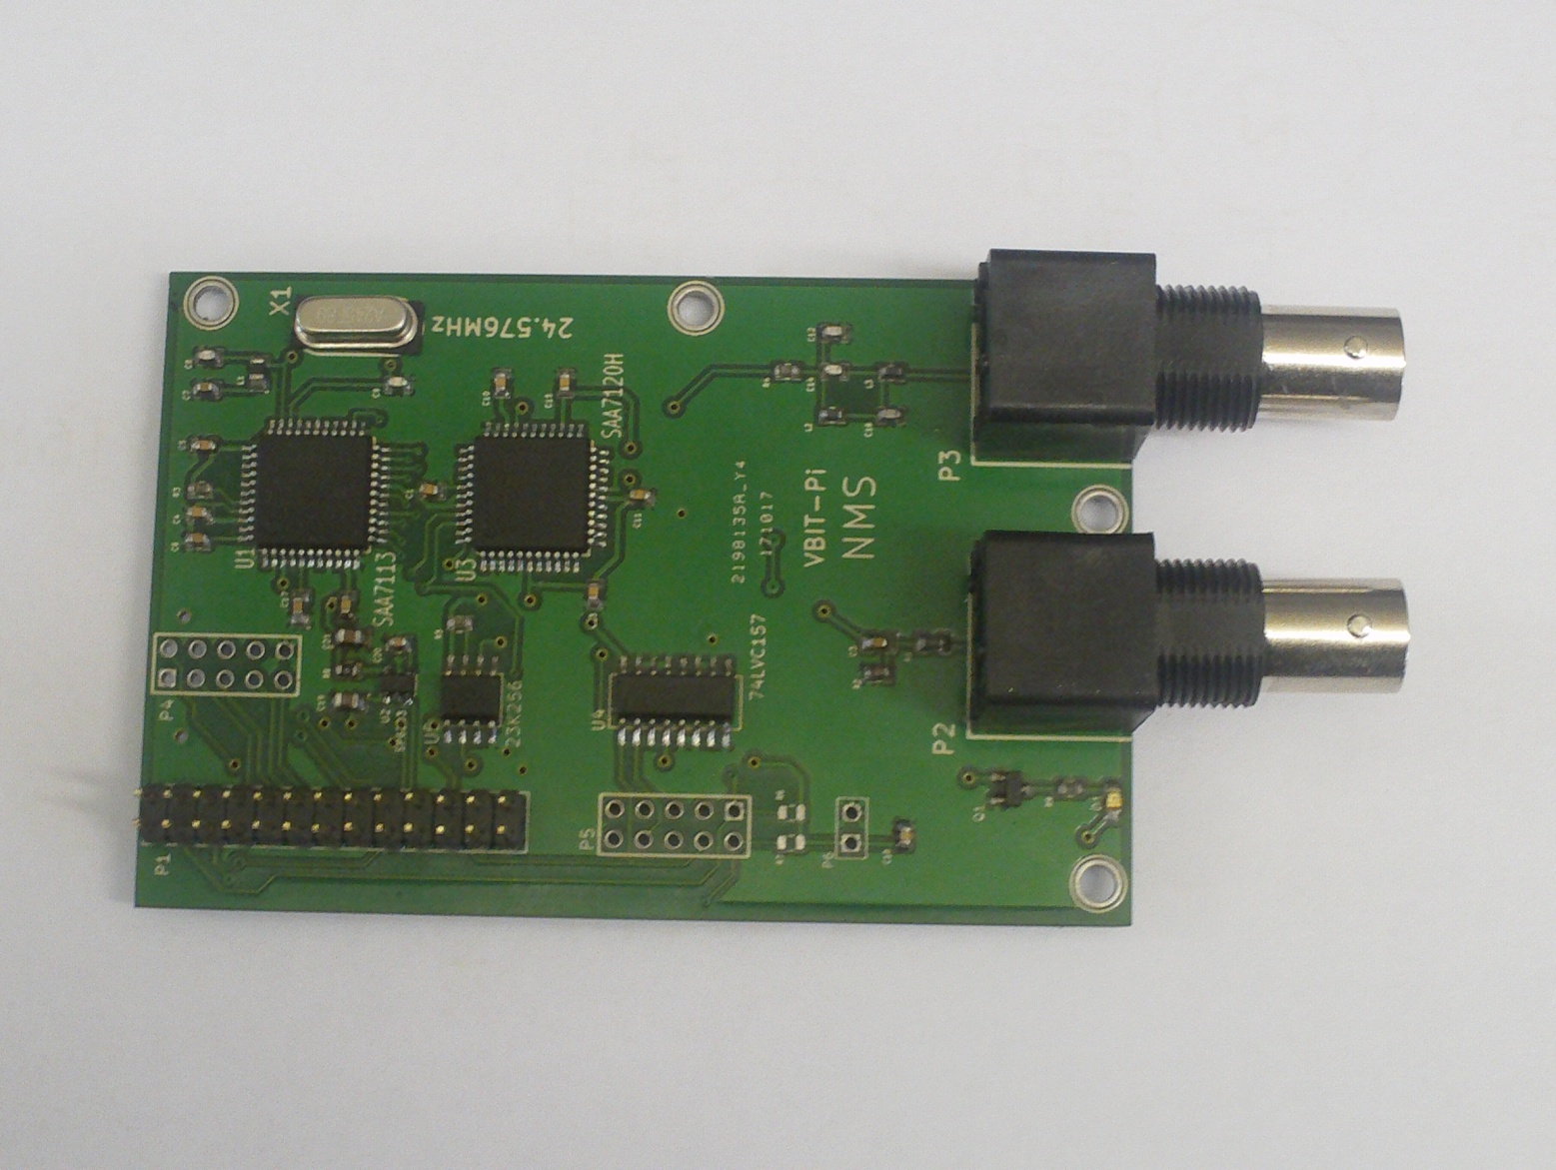

Before we start

This guide assumes you’ve already got a Raspberry Pi running the latest version of Raspbian and you’re capable of either SSH-ing into it or using the terminal on the Pi itself. If not, you’d probably be better getting the readymade SD card which comes with everything already installed and ready to go.

Software Installation

Make sure your Pi is up-to-date:

sudo apt-get update

sudo apt-get upgrade

(If it’s been a while since you last updated Raspbian, this could take some time).

Make sure you’re in the home directory:

cd ~

Download the VBIT2 Installer:

wget -N <https://raw.githubusercontent.com/peterkvt80/vbit2/master/getvbit2>

(All on one line).

Give it execution permission:

sudo chmod +x getvbit2

And run it.

./getvbit2

(Again, this could take some time).

Clone the code into ‘vbit-py’:

git clone <https://github.com/peterkvt80/vbit-py.git>

(All one line)

Install various libraries and tools:

sudo apt-get install python3-dev i2c-tools rpi.gpio python3-smbus python3-spidev

Finally, you’ll need to enable SPI and I2C on your Pi:

sudo raspi-config

Scroll down to ‘Interfacing options’ and hit enter. Scroll down to SPI and hit enter. Hit ‘yes’. Repeat for I2C.

Hardware setup

Shutdown and unplug your Pi first.

sudo halt

The VBIT-Pi was designed for the original Raspberry Pi, which had only 26 GPIO Lines. It will still work with newer Pis, but make sure the pins are in the right place. If you’re using a 40-pin ribbon cable, only the **first** 26 pins should be plugged into the VBIT-Pi, with the leftover socket hanging in mid air. If you’re using a 26-pin ribbon cable, it should be plugged into the first 26 pins on the Raspberry Pi’s GPIO header. Be careful! If you plug into the wrong pins on either the Raspberry Pi or VBIT-Pi, you could cause damage to both.

Connect a PAL video source the the left-hand BNC Connector. Connect your teletext TV to the right hand one.

Plug your Pi back into power. It should boot up normally. Log into the terminal and type:

cd ~/vbit-py

./vbit

The VBIT-Pi’s LED should start flickering and the TV will start showing the video signal. Pressing the Teletext button should bring up the Teefax Service.

Troubleshooting

If the LED is flickering but your TV doesn’t detect teletext, try reseating the ribbon cable.

If the LED isn’t flickering or the video signal looks messed up, there’s probably something wrong with your input signal. It has to be quite a steady signal to work properly, which rules out VCRs and some gaming devices. Things like DVD players and old camcorders seem to work well.